1. Array
Array is a linear data structure that stores a collection of elements of the same data type. Elements are allocated contiguous memory, allowing for constant-time access. Each element has a unique index number.
- Operations on Array:
  - Traversal: Iterating through the elements of an array.
  - Insertion: Adding an element to the array at a specific index.
  - Deletion: Removing an element from the array at a specific index.
  - Searching: Finding an element in the array by its value or index.
- Types of Arrays:
  - One-dimensional array: A simple array with a single dimension.
  - Multidimensional array: An array with multiple dimensions, such as a matrix.
- Applications of Array:
  - Storing data in a sequential manner
  - Implementing queues, stacks, and other data structures
  - Representing matrices and tables
Advantages :
- Random Access
2) Cache Friendliness

Cache fastest memory which is close to RAM.

- Dynamic Sized Arrays :
C++ - Vector
Java - ArrayList
Python - List
These arrays increase their size as soon as capacity becomes Full.
Moslty will use dynamic sized arrays only.

- Operations on Arrays :-

Search :-
O(n) for unsorted array. (Travarse whole array)
O(logn) for sorted array. (Binary Search Algo)

Insert :-
O(n) - traverse from back till position and then insert and till then move elements ahead 1 position.
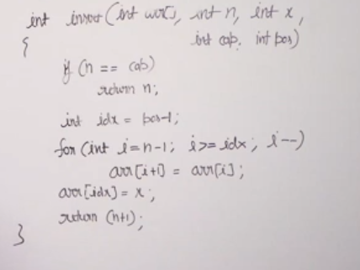

Delete :-
O(n) - Traverse from start till exact element and break loop and move next elements leftwards one by one.
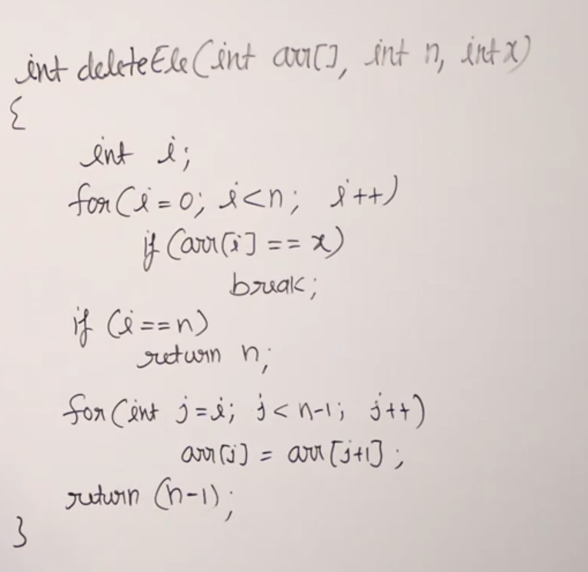
Get ith Element : O(1)
Update ith Element : O(1)
Insert at end and delete at end : O(1)

The most efficient sorting algorithms have the time complexity of O(n),
Bucket sort with time complexity of O(n)
And for searching its max logn

- Some Comman Problems :-
Left Rotate an Array by D places
- Left Rotate by 1
do this d times using recalling it.
- Copy first d elements and then rotate rest then put copied d elements.
- below
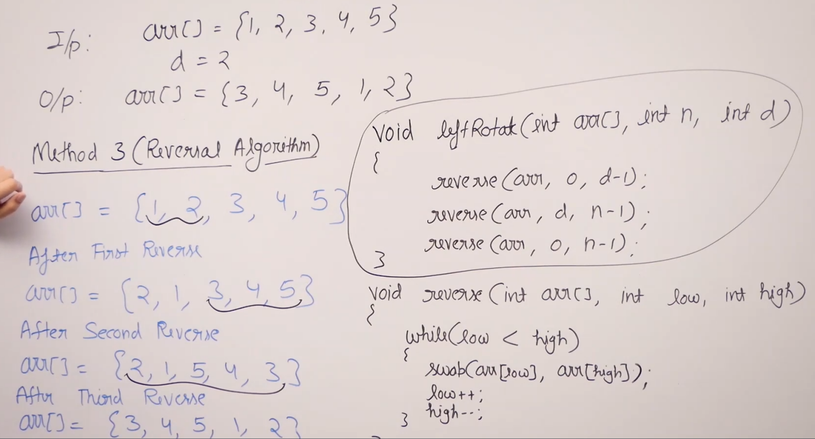
We use three reversals to rotate the array in-place because a single reverse only flips order, while three reversals rearrange segments to preserve relative order and achieve rotation in O(n) time and O(1) space
Moves zeros to end
keep using variable that points something in array helps in getting linear solutions.
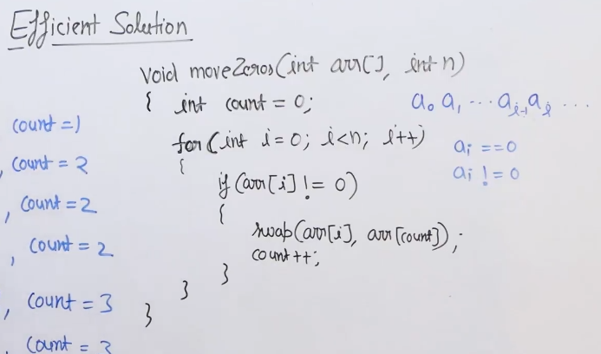

class Solution {
void pushZerosToEnd(int[] arr) {
int p = 0;

for (int i = 0; i < arr.length; i++) {
if (arr[i] != 0) {
arr[p++] = arr[i];
}
}
while (p < arr.length) {
arr[p++] = 0;
}
}
}

We copy all non-zero elements to the front using a pointer, then fill the remaining positions with zero. This avoids swaps and preserves order in O(n) time.

- Two pointer approach.
Use Two Pointers when:
Working with arrays or strings
Data is sorted (very important)
Need to find:
Pairs
Reverse
Move elements
Remove duplicates
Need traversal from:
Both ends
Different speeds
Examples:
Move zeros to end
Reverse array
Pair with target sum (sorted array)
Palindrome check
Cycle detection
Array compaction
Remove duplicates..
Pointers move:
left–right OR slow–fast

Reverse an Array
int[] arr = {1, 2, 3, 4};
int left = 0, right = arr.length - 1;

while (left < right) {
int temp = arr[left];
arr[left] = arr[right];
arr[right] = temp;
left++;
right--;
}
Pair with Target Sum (Sorted Array)
int[] arr = {1, 2, 3, 4, 6};
int target = 6;

int left = 0, right = arr.length - 1;

while (left < right) {
int sum = arr[left] + arr[right];
if (sum == target) {
System.out.println(left + " " + right);
break;
} else if (sum < target) {
left++;
} else {
right--;
}
}

